**DAILY ONLINE ACTIVITIES SUMMARY**

|  |  |  |  |  |  |  |  |  |
| --- | --- | --- | --- | --- | --- | --- | --- | --- |
| **Date:** | **20-6-2020** | | | | | **Name:** | **Prajna** | |
| **Sem & Sec** | **8th sem ‘B’** | | | | | **USN:** | **4AL16CS067** | |
| **Online Test Summary** | | | | | | | | |
| **Subject** | | **-** | | | | | | |
| **Max. Marks** | | **-** | | **Score** | | | **-** | |
| **Certification Course Summary** | | | | | | | | |
| **Course** | **Introduction to python programming** | | | | | | | |
| **Certificate Provider** | | | **Great learning** | | **Duration** | | | **2hrs** |
| **Coding Challenges** | | | | | | | | |
| **Problem Statement:**1**.** Write a c program to insert element in to array. | | | | | | | | |
| **Status: Completed** | | | | | | | | |
| **Uploaded the report in GitHub**  **GitHub link:** | | | | | **Yes**  **https://github.com/alvas-education-foundation/prajna_k** | | | |
| **If yes Repository name** | | | | | **prajna_k** | | | |
| **Uploaded the report in slack** | | | | | **yes** | | | |

Online Test Details: (Attach the snapshot and briefly write the report for the same)

Certification Course Details: (Attach the snapshot and briefly write the report for the same)

Coding Challenges Details: (Attach the snapshot and briefly write the report for the same)

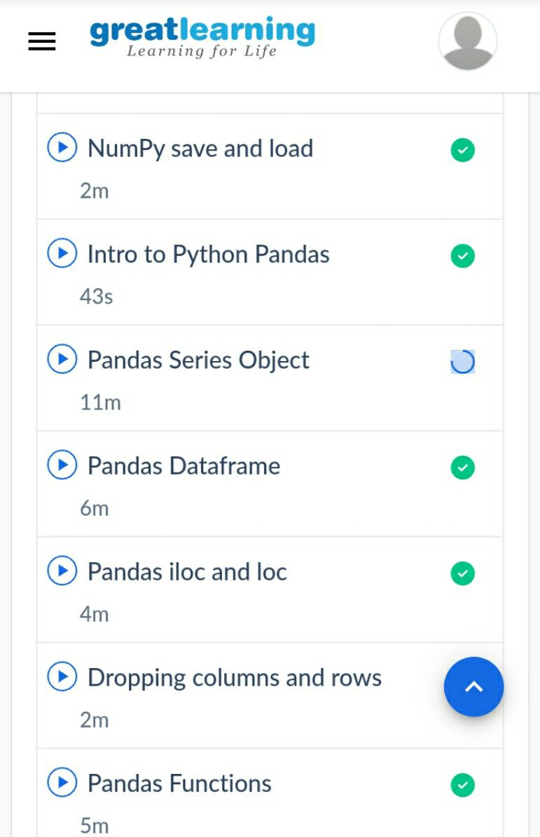2) certification course

3) coding challenges

#include <stdio.h>

void main()

{

int arr1[100],i,n,p,x; printf("\n\nInsert New value in the unsorted array : \n ");

printf("-----------------------------------------\n");

printf("Input the size of array : ");

scanf("%d", &n);

printf("Input %d elements in the array in ascending order:\n",n);

for(i=0;i<n;i++)

{

printf("element - %d : ",i);

scanf("%d",&arr1[i]);

}

printf("Input the value to be inserted : ");

scanf("%d",&x);

printf("Input the Position, where the value to be inserted :");

scanf("%d",&p);

printf("The current list of the array :\n");

for(i=0;i<n;i++)

printf("% 5d",arr1[i]);

for(i=n;i>=p;i--)

arr1[i]= arr1[i-1];

arr1[p-1]=x;

printf("\n\nAfter Insert the element the new list is :\n");

for(i=0;i<=n;i++)

printf("% 5d",arr1[i]);

printf("\n\n");

}

|  |
| --- |
|  |
|  |  |
|  |  |
|  |  |
|  |  |
|  |  |